***Template of the extended abstracts***

|  |  |  |
| --- | --- | --- |
| Author 1  *Department Name*  *University Name*  email@email.email | Author 2  *Department Name*  *University Name*  email@email.email | Author 3  *Department Name*  *University Name*  email@email.email |

**Abstract** – This template explains how to prepare the extended abstract for publication in conference SITE. Authors are advised to carefully read those instructions and follow them.

**Keywords** – list the keywords covered in your paper...

**INTRODUCTION**

This template provides the essential guidelines for preparing a 2-page extended abstract, which should be written entirely in English or French.

Please ensure that the extended abstract is written in Microsoft Word or LaTeX format, utilizing a two-column layout with 12-point Times New Roman font. It should comprehensively explain the aim and scope of your study, detail the materials and methods employed, present the obtained results, and summarize the main conclusions drawn.

**BODY OF THE ABSTRACT**

1. **Format**

The body of the extended abstract can be divided into paragraphs for improved organization and readability. You may choose to include subtitles to further structure the content if desired.

The structure of the body of the extended abstract should be:

Methodology: Describe the methodology, experimental setup, or theoretical framework used in the research.

Provide sufficient details to allow the reader to understand and evaluate the validity of the study.

Results and discussions: Present the main results, findings, or outcomes of the research.

Interpret the results and discuss their implications in relation to the research objectives or research questions.

Clearly label and reference any visual aids used.

Additionally, figures and tables can be incorporated into the extended abstract to visually illustrate and support the work being presented. These visual elements can enhance the clarity and understanding of your research.

1. **Figure, table and equations**

These are examples of figure and table. They should be referred to in the main text of the abstract.

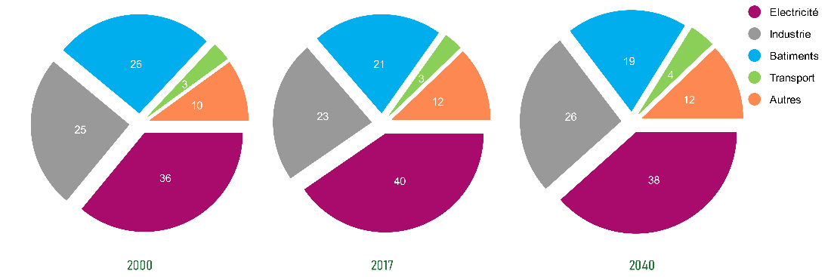

Figure 1: Title of the figure

Table 1: Title of the table

|  |  |
| --- | --- |
|  | **Column A** |
| **Row A** | data |
| **Row B** | 123 |

When including equations in your extended abstract, please ensure to label them as in Equation (1), with a number towards the right margin, if there is more than one equation.

$B = \int_{ }^{ }{sinθ}dθ$ (1)

**SUBMISSION**

The extended abstract must be submitted in pdf format, using Microsoft Conference Management Toolkit

(<https://cmt3.research.microsoft.com/SITE2025/Submission/Index>), or using the submission page on the conference web site <https://site-conf.com/>

**CONCLUSION**

Summarize the key points and conclusions drawn from the research.

Highlight the significance and potential impact of the findings.

Avoid introducing new information or ideas in the conclusion.

**ACKNOWLEDGMENT**

An optional section for acknowledgments may be included in the extended abstract. In this section, you can acknowledge any individuals, institutions, or organizations that have contributed to your research or the writing process of the extended abstract.

**REFERENCES**

Include a list of cited references following a specified citation style. Wikipedia and similar websites may not be used as references.

Author(s) name(s), journal title / book title, article title / chapter title, year of publication, volume and issue / book chapter, and the pagination must be present.

[1] Author Name, *Title of the Paper*, Journal Name, vol. 1, no. 1, pp. 1-10, Year.

[2] Author Name, *Title of the Book*, Publisher, Year.